# Emptoris Contract Management V10.0.1 Preparation Download Authoring Tool, set Word Options, establish Internet Explorer Settings

# If you will be using your own laptop as Contract Management client (not the case if the IRLP environment is used), you will need to follow the steps in this document prior to or during the workshop. These prepare the Contract Management Authoring Tool and ensure that the settings on your machine are correct. If more information is required, see the Contract Management User Guide, section “Getting Started”.

### Download the Authoring Tool

NOTE: The workshop leader may have already provided you with the two Authoring Tool files listed below. If so, follow these steps; otherwise, jump to step 1 below.

* If you have previously installed the tool, then remove it by following these steps (from the User Guide):
  + Exit Word.
  + Use Windows Control Panel > Programs and Features to uninstall the Emptoris Authoring Tool program.
  + Clear or rename the folder the tool is/was in, such as C:\Users\<user_name>\AppData\Roaming\Microsoft\Templates\Emptoris. One way to find this folder is by searching for ECMWordAddin.log
  + Rename the file normal.dotm, in the Templates folder that is the parent of the Emptoris folder in the previous bullet.
* Store the two supplied Authoring Tool files. They must be in the same folder.
* Run setup.exe from the above folder and follow the instructions.
* After installation, open Word and do a quick verification of the tool by making sure that the box beside ECMWordAddin is checked – see the instructions at the end of this document. Also, find ECMWordAddin.log (see above) and see what it says.
* Now continue at the Browser section below.

1. Access the Emptoris test system at the URL provided by the workshop leader.
2. Login to Emptoris Strategic Supply Management using a login and password provided.
3. Once you have logged into the system, click on the link for Contract Management.

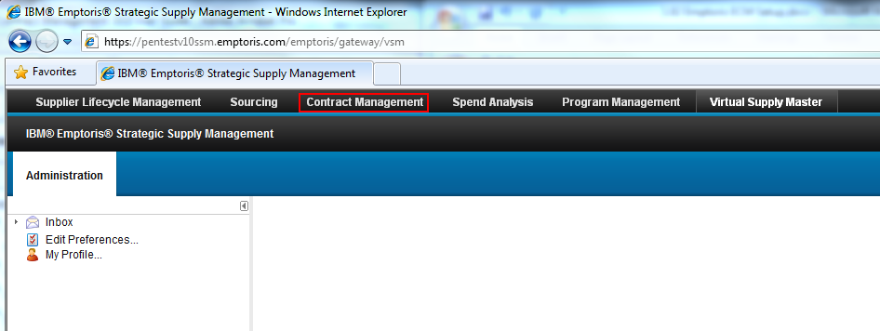

1. Click the Tools link, and from the drop down menu, select “Download Authoring Tool”.

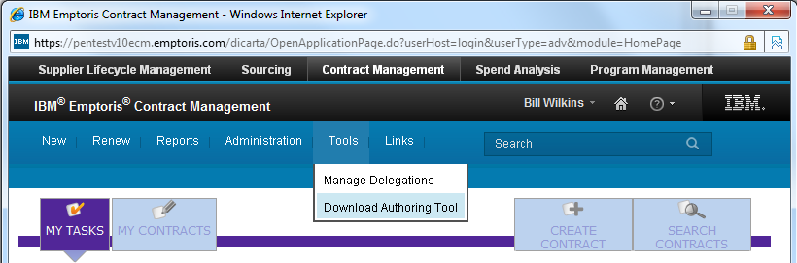

1. You should see the following window:

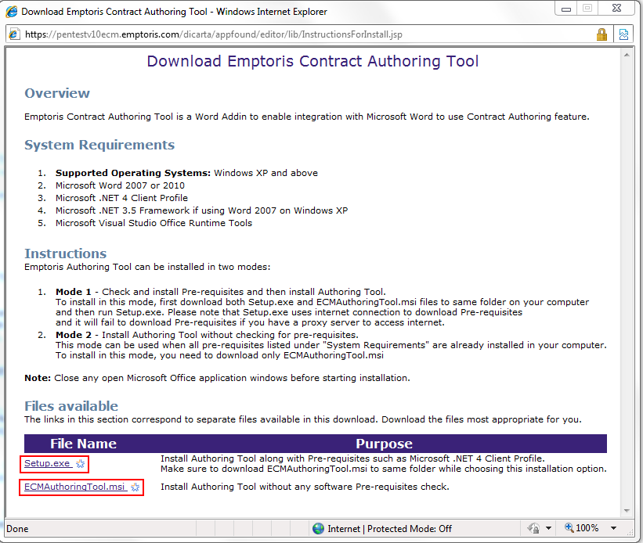

1. At the bottom of the page under “File Name”, click on ***Setup.exe*** and then select ***Save*** when the dialogue box opens***.*** Save it to your desktop, then click **Close**.
2. Click the ***ECMAuthoringTool.msi*** link and select ***Save*** when the dialogue box opens. Save it to your desktop (same folder as setup.exe), then click **Close**.
3. Go to your desktop and double click on the Setup.exe icon. 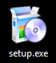 Click Run to confirm that you want to run Setup.
4. Follow the instructions as you go through the steps of the Emptoris Authoring Tool Setup Wizard. Note that you do **not** need to execute ECMAuthoringTool.msi.

## Internet Explorer/Browser Configuration and Setup

Now, make sure that your Internet Explorer settings are properly configured.

1. Open Internet Explorer (IE).
2. Go to ***Tools*** and then select ***Internet Options.***
3. Click the ***Security*** tab.
4. You will now need to choose a zone in which you will run Emptoris Contract Management. These instructions assume you will use the ***Trusted Sites*** zone. Click on that zone, or whichever zone you choose, in the top box.

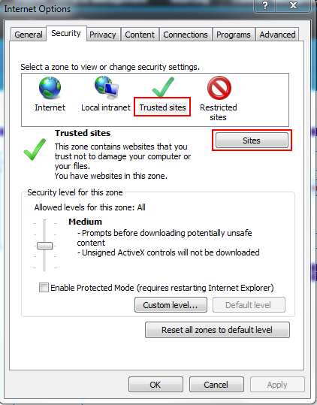

1. Click the ***Sites*** box. The testing system URL should be supplied in the top box. Click on ***Add*** to add it as a trusted site, then click on ***Close***.

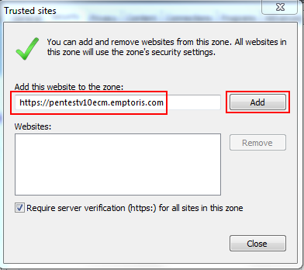

1. Click on the **Custom Level** box.

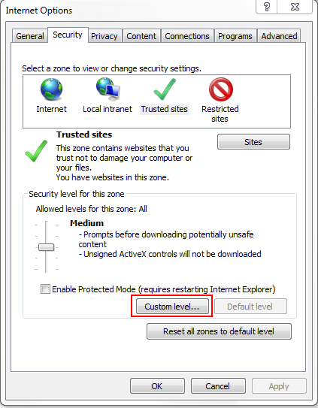

1. Edit the settings: Use the scroll bar to move down to the **Downloads** section.
   * 1. Enable ***Automatic Prompting***
     2. Enable ***File Download***
     3. Click ***OK*** when finished, then close out of the Internet Settings

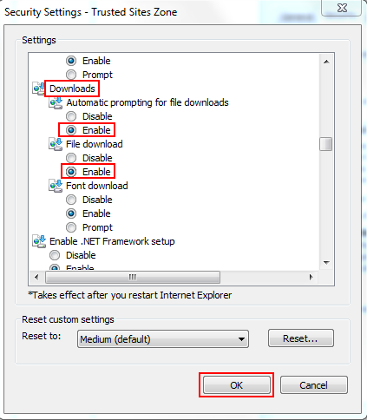

### Test the Editor

Check that the Emptoris Word Editor opens properly. This requires opening a contract for which you have permission to edit language. A simple way to guarantee you have permission is to create a new contract (as a BAM user). Ask if you need help either creating a contract or finding one to edit.

Open the contract, then click the Language tab.

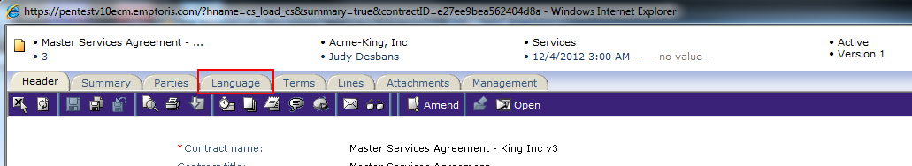

The contract language is displayed. Click the **Open** (Microsoft Word) button.

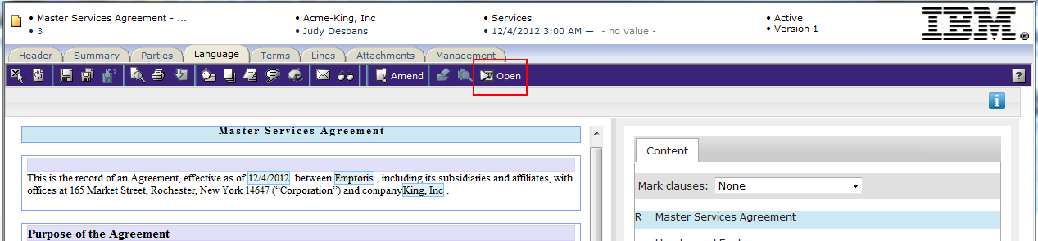

You are prompted to open or save the file. Click on **Open**.

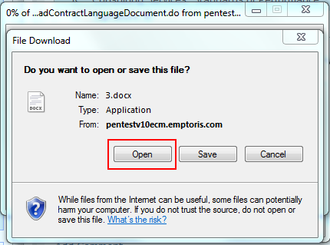

You may see the following warning window, which you can ignore.

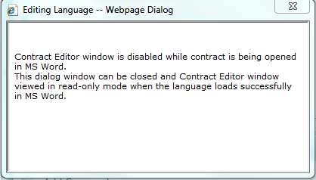

The Word file opens with the Emptoris Ribbon enabled:



## Word Settings (If editor fails to open)

If the Word file fails to open, or the Word Editor does not appear, open Microsoft Word and follow the following steps:

In the top left corner of Word, click the Microsoft Office Button.  This opens the following screen. Click the ***Word Options*** button at the bottom of the screen.

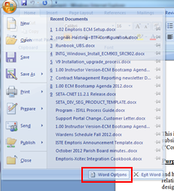

Open the ***Trust Center*** settings and click ***Trust Center Settings*** in the bottom right corner.

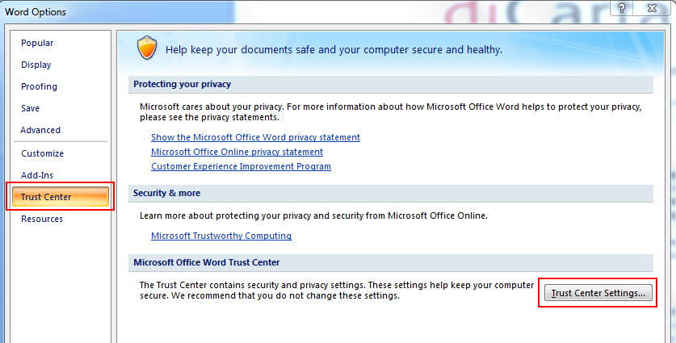

Go to Trusted Locations and click ***Add new location...*** button. Check the box to include Subfolders on templates and then click OK.

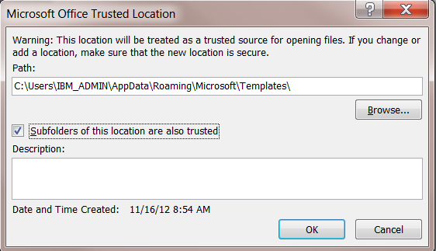

Now we will make sure that the Emptoris Contract Management Add-in is set to load. Go to ***Word Options***, then select ***Add-Ins***. In the ***Manage:*** field at the bottom of the screen, make sure that ***Com Add-ins*** is selected, then click ***Go***.

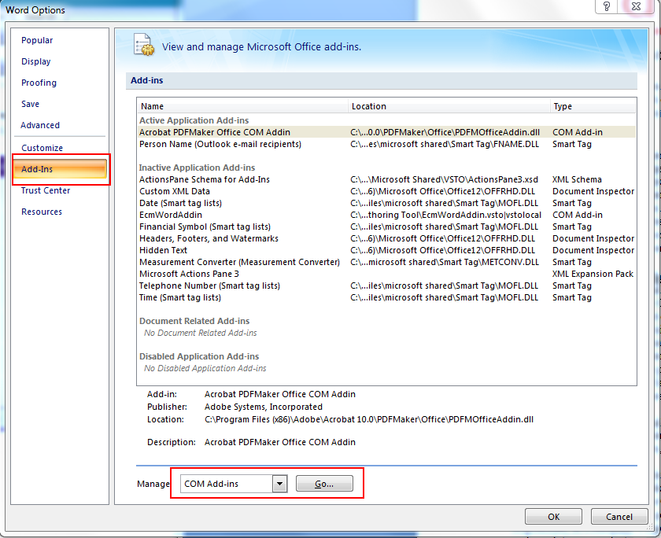

Enable the Contract Management Add-in by placing a check mark next to ECMWordAddin, then click **OK.** (However, this setting may not persist. Exit the dialog and come back in, and you may see that the box is unchecked again, which means there’s still a problem.)

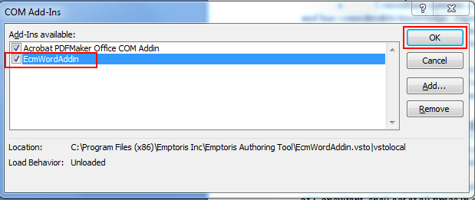

Close Word, then log out of Emptoris Strategic Supply Management (SSM). Log back into SSM, then choose Contract Management and perform Section III, “Test the Editor”, once again.

If the Word add-in does not open, you can get assistance from the workshop leader, or open a support ticket with Emptoris Support at the following email address: [EmptorisSupport@us.ibm.com](mailto:EmptorisSupport@us.ibm.com?subject=Contract%20Management%20issue%20interfacing%20with%20Word) For other support options, click on go to <http://www-01.ibm.com/software/procurement-solutions/emptoris/customer-support/>